**App for Happiness**

*Introduction:*

Everything in the world can be bought by money. Everything but happiness. No matter how much you spend on it, the happiness you get from it is temporary. You cannot give a purse to a person who is depressed or in anxiety. You must take proper care of that person by showing him/her to a professional. In this modern world, you can even make that person sign up for an app that helps them control their depression/anxiety when they are on their own.

*Problem Statement:*

As the world around us is becoming more stressful with each passing day and life is becoming faster, people tend to forget about their happiness and well-being as they tend to get lost in the survival mindset. This app would be a solution for all the resources that are needed to indulge in mindfulness and happiness-related activities.

*Goals and Objective:*

As the problem of achieving happiness is vast, there are many existing approaches taken by certain apps. The problem of stress is common for everyone and the best way to release it is journaling and meditation. This approach has been taken by many apps. Some apps have also taken the approach of giving exercises on a daily/weekly basis, giving points to the user to level up, exactly like a game. The app that was created by me (Navya Shah) has taken a different approach. Nobody knows the mental pain anyone goes through; everybody has different problems. But happiness is contagious. Everybody can share their moments of happiness by using 'The Cozy Corner' where you can share it either in the form of video, image, or audio.

*Approach:*

As the vision was clear for how my website would look and function, it was time to bring my idea out of my head.

* The first step was to decide the theme according to the logo and the name of the website i.e. 'The Cozy Corner'. The home page of the website consists of a description of how the cozy corner is not about any location where you must be yourself. Anywhere, anytime you can be in your sanctuary with 'The Cozy Corner'.

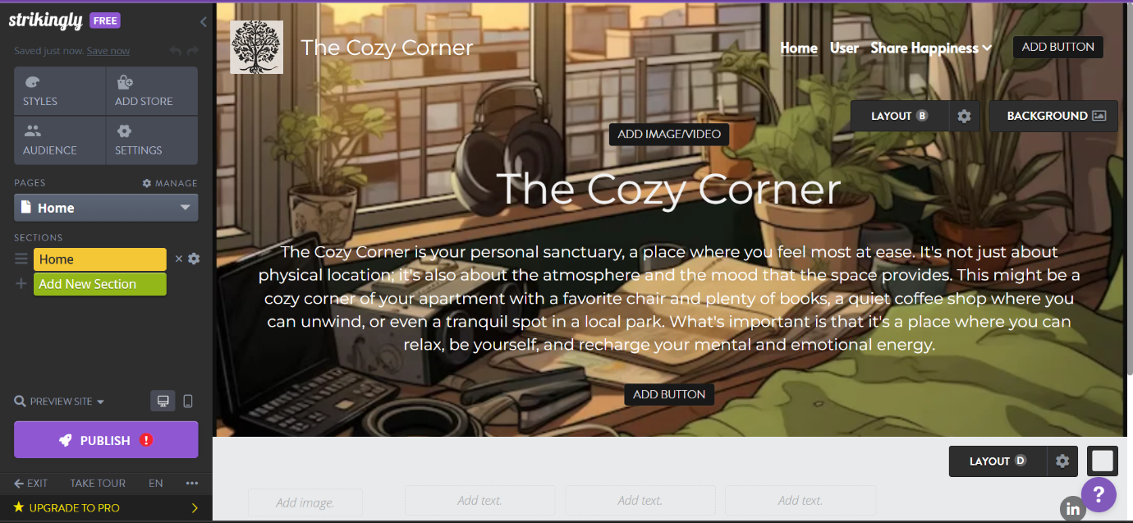

The second step was to create a user information page where users can update their information. Even if they do not want to give their info, it is fine as the website will still work for them too. The important thing is that they feel safe when using this website.

* The most important thing in 'The Cozy Corner' is the user input and user interaction with each other. So, google being the best medium for such an interface, made this possible as users just had to click on the link which would take them to the Google Forms tab, where they to upload any happy message or memory in the form of audio, video, or image.
* If the user wants to see where their uploads are, they must click on the Google Drive link where they can see theirs as well as others.

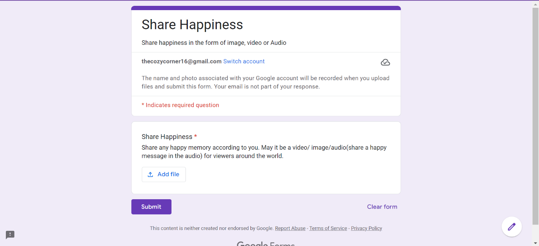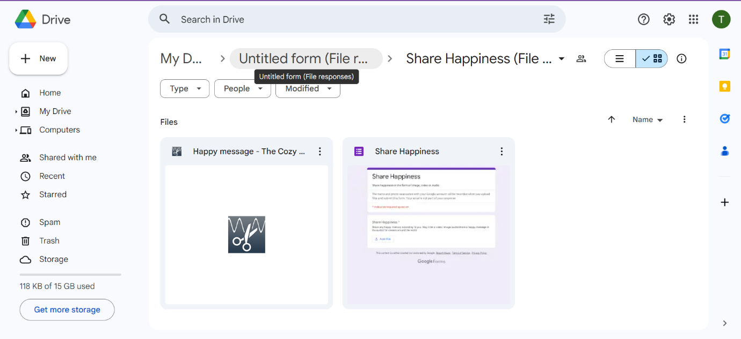

*Results and Conclusion:*

My website: - <https://the-cozy-corner.mystrikingly.com/>

The app's user-friendly design and effective features contribute to a supportive environment that will bring happiness to the user. The google drive has created a sense of connectedness among users, creating a supportive environment for sharing happiness. *References:*

<https://www.strikingly.com/>

<https://www.google.com/forms/about/>

<https://drive.google.com/>

<https://chat.openai.com/>

<https://app.grammarly.com/>

[The 9 Best Happiness Apps for 2024 - Happier Human](https://www.happierhuman.com/best-happiness-apps/)

[17 no-code apps &amp; tools to help build your next startup in 2023 (webflow.com)](https://webflow.com/blog/no-code-apps)

[No Code Revolution | Where to start with No Code Tools (youtube.com)](https://www.youtube.com/watch?v=nOPaOWcAO38)

<https://imissmycafe.com/>

<https://www.canva.com/>